For Max_Carprice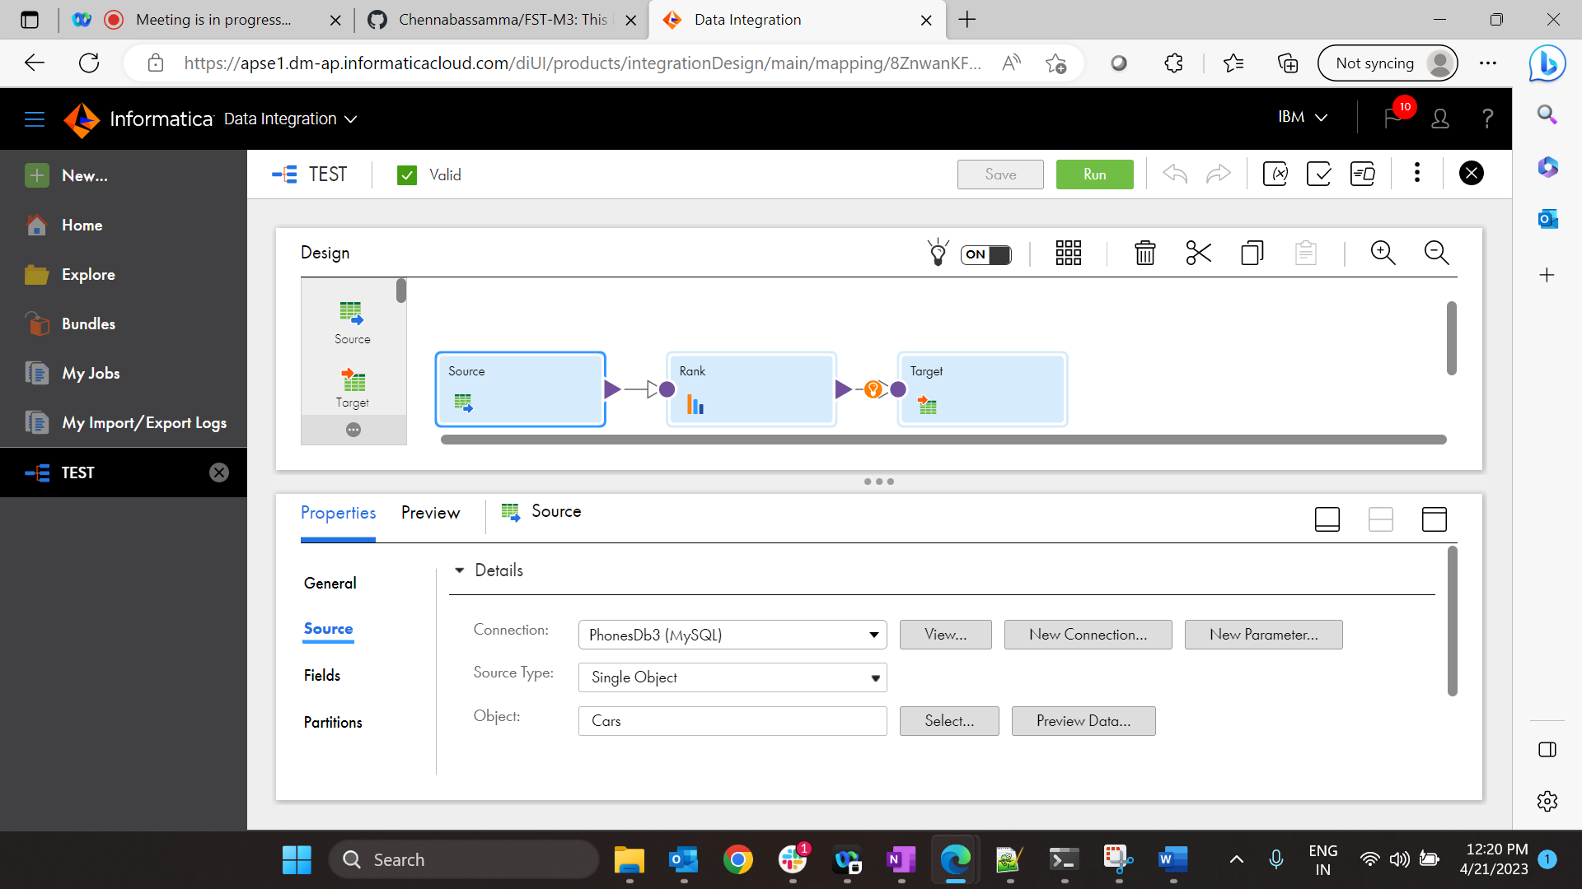

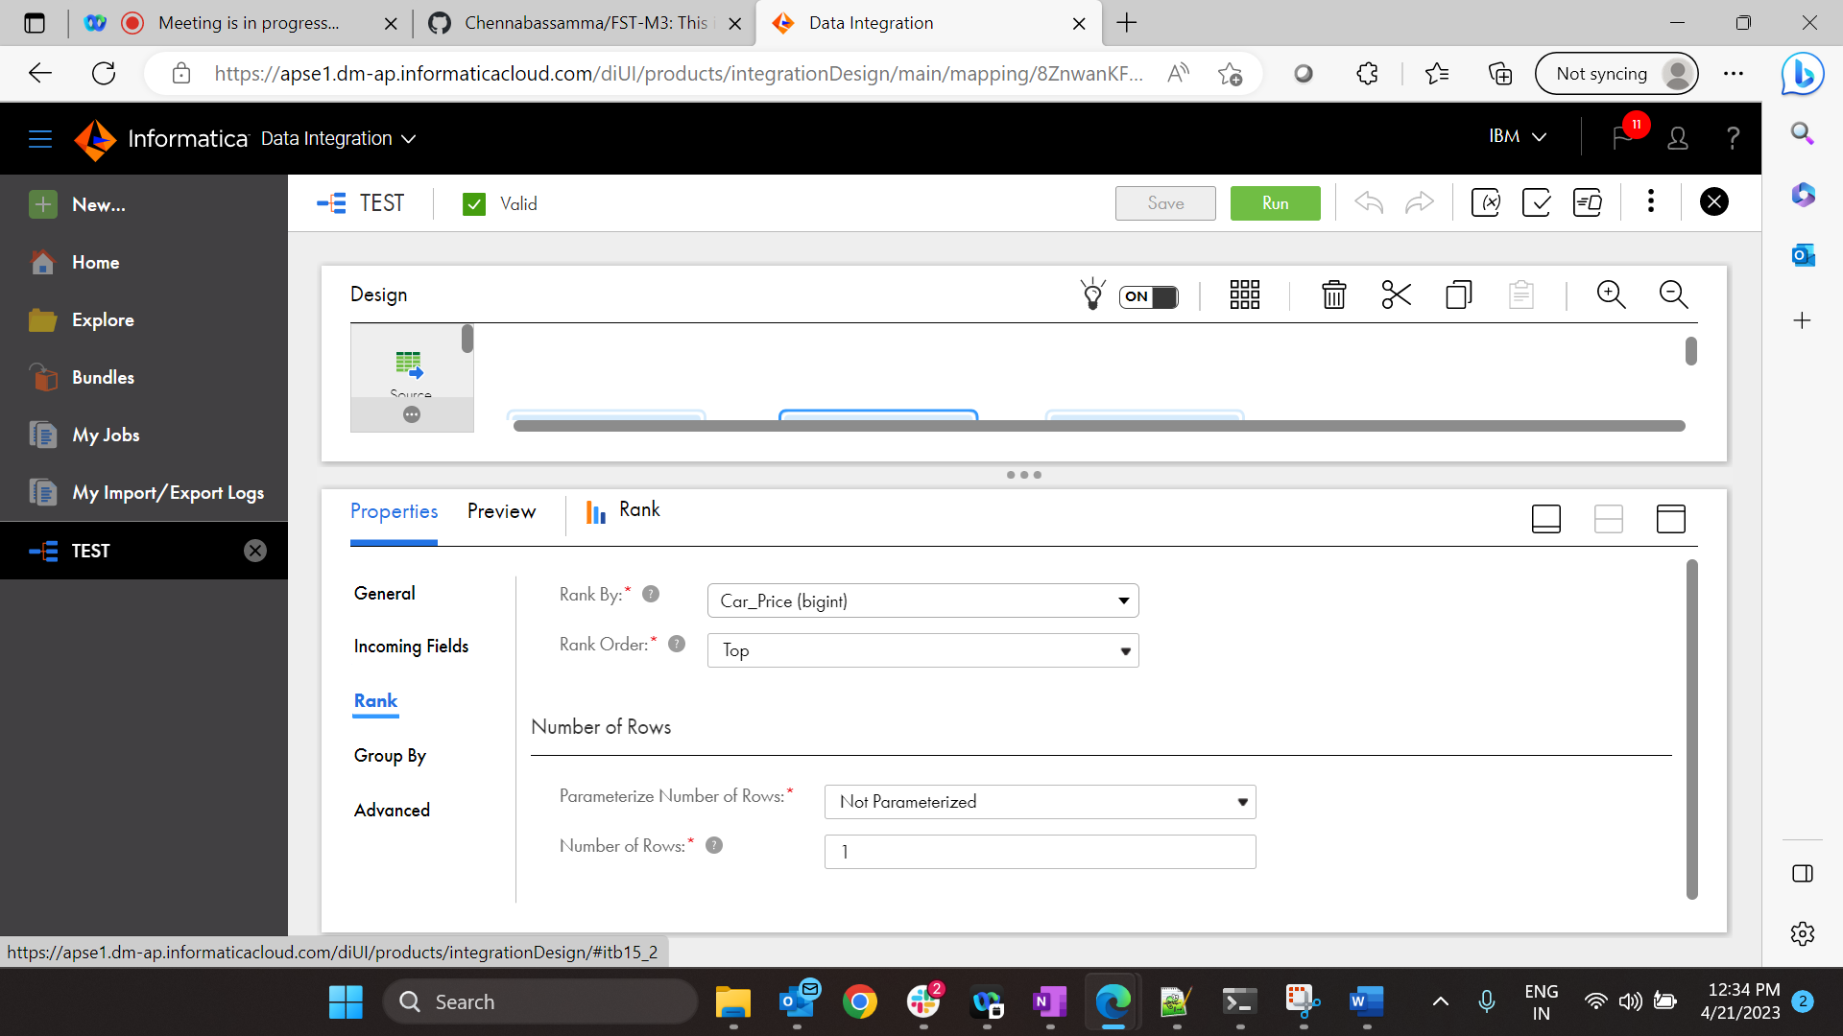

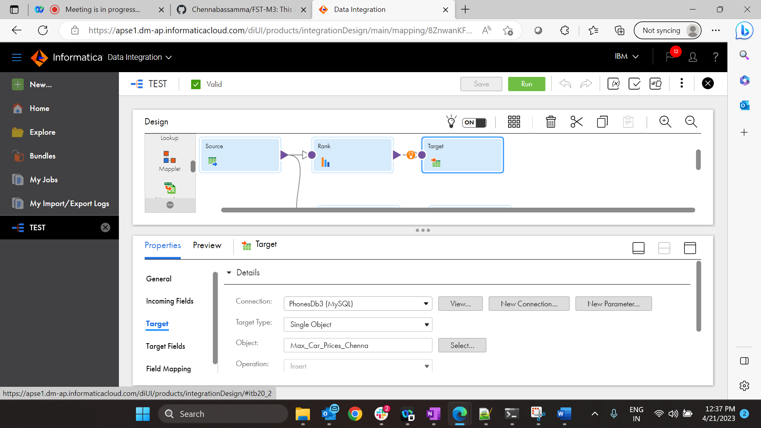



Min car Price_Chenna

